Assignment 1

1. **Relative vs Absolute**

“position: relative” places an element relative to its current position without changing the layout around it, whereas “position: absolute” places an element relative to its parent’s position and changing the layout around it.

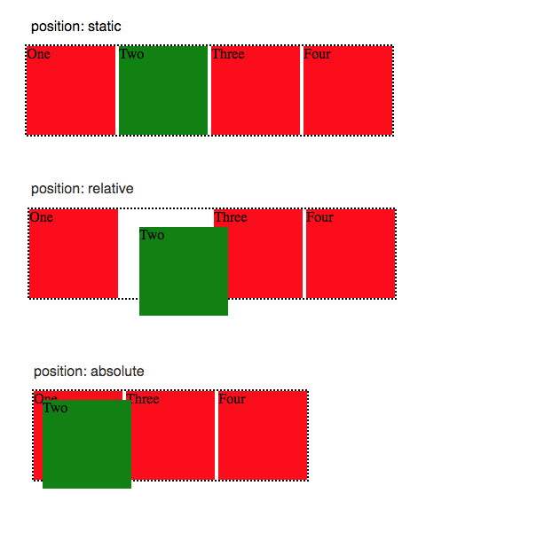

1. **CSS Box sizing**

The difference between Margin and Padding CSS box sizing is that the Margin is basically how much distance the box wants to be with other boxes around it whereas Padding is how much distance the box wants to be relative to the boxes inside of it.

